The Roses of 3400 Laguna
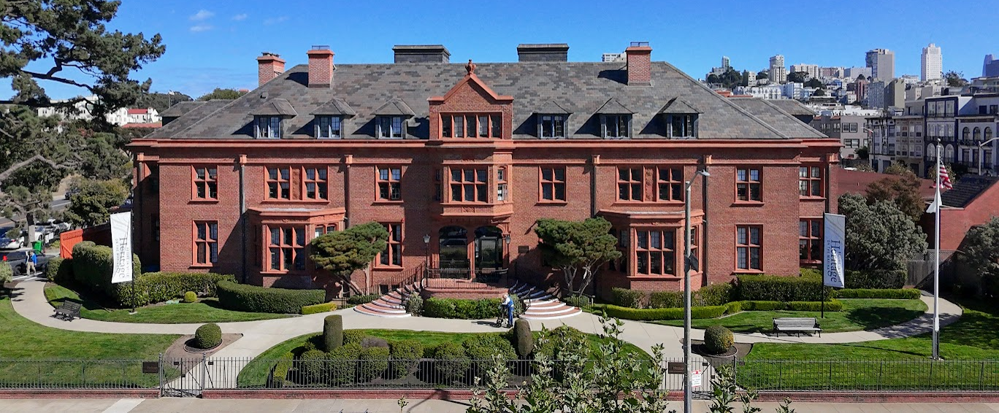
Theo Armour / t.armour@gmail.com / 415 828 0000

Preface
This paper is submitted as a comment on the Draft EIR prepared by San Francisco Planning Case Number 2022-009819ENV and is reference to section on “Character-Defining Features” listed on pages 3.B-15 to 3.B-20 and to Landmark Designation Recommendation, record number 2024-001869DES.
I am a resident of Heritage on the Marina at 3400 Laguna. My intention here is to bring attention and to record the existence of elements of high architectural quality in the project that are not mentioned in the draft EIR.
I am a former architect. Among other works, I designed and managed the renovation of over ninety houses in London and was number three in an architectural practice that designed twelve mass transit railway stations in Hong Kong. Working for Autodesk, I was Program Manager for three releases of AutoCAD.
All the photographs herein were taken by me.

Introduction
One of the remarkable aspects of the Julia Morgan building is the quality, consistency and quantity of particular decorative items. Representations of roses, similar to a Tudor Rose or Luther Rose, are repeated several dozen times in at least twelve different expressions. Trefoils and berries, while not as numerous, may also be observed in a variety of locations. The quality and repetition of these decorative details are hallmarks of great architecture.
- https://en.wikipedia.org/wiki/Tudor_rose
- https://en.wikipedia.org/wiki/Luther_rose
The interesting question here is: How important were these roses to Julia Morgan, the managers of the San Francisco Ladies Protection and Relief Society as the client and to the residents themselves?
Certainly, the project as a whole was quite significant for Julia Morgan. The commission she received the year she worked in the project, 1924, was the third largest that year out of forty-five projects list in her accounts:
- http://www.coffmanbooks.com/HAMpdfs/30_HAM_AI.pdf
It is my intention to explore this matter more deeply, to seek references to the roses in correspondence and to source the brief that Julia Morgan was trying to carry out.
Elsewhere I have investigated the symbology of the rose and its possible uses and meaning. All my research so far has been based on speculation and not on any documentation contemporary with the design of the building. I intend to carry out further research into this probably fascinating topic, but any comments now would be outside the purview of an EIR.
The primary purpose of this effort is to bring to your attention:
- The deep level of consistency and continuity of Julia Morgan’s design as a whole
- The very high level of workmanship and artistic flair embedded in the stonework of the project
- Consideration that the roses be listed as “Character-Defining Features”
- The possibility of you smiling as you walk around the building and say to yourself: “Ah, there’s another one!”

The following sections catalog all the roses and other symbols that I have identified so far:
- Three Roses in Two Terracotta Panels
- Dozens of Roses in Roundels in the Parapet
- Roses in Two Front Bay Terracotta Panels
- Roses to Sides of Front Bay Corbels
- Two Roses in Three Pilaster Capitals
- Roses in Spandrels to Front Door Arches
- Roses in Window Transoms
- Rosebuds in Window Spandrels
- “Roses” in Brickwork
- Four Roses in Parlor Mantlepiece
- Roses as Brass Ornaments to Fireplace and Windows
- Roses in Corridor Column Capitals
- Four Roses in Chapel Alter
- Roses in Folding Screen

Three Roses in Two Terracotta Panels
There are three roses in the terracotta panels between the second story windows above the two ground floor bays. Each rose is composed of three nested roses. In the outer rose there are eight outside petals with gaps between petals at the quadrants. The two inside roses appear to have four petals each. Surrounding the roses there is a garland or vine with berries and leaves of a type not yet identified. In each of the corners there is a rosebud. The meticulous carving indicates a skilled level of craftsmanship.
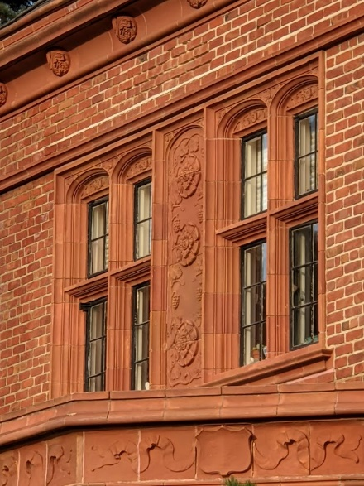
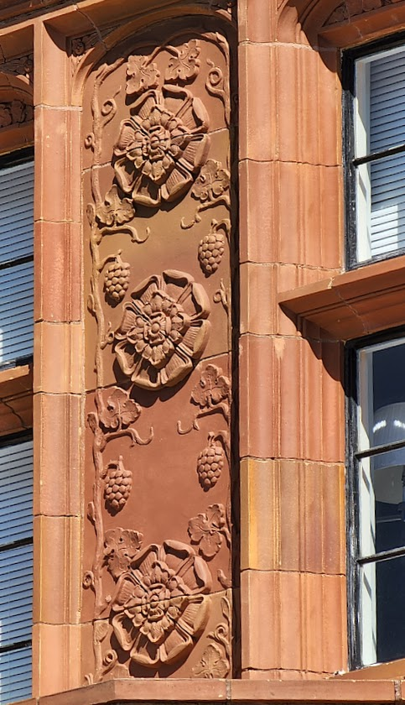
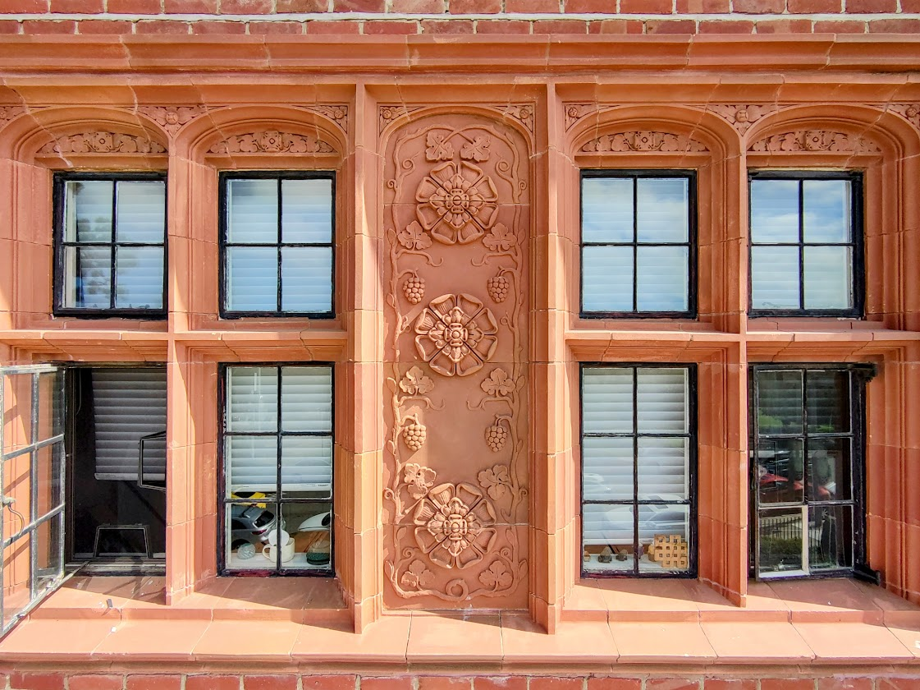

Dozens of Roses in Roundels in the Parapet
Every few feet along the parapet that surround the entire building there are “roundels” or decorative circular medallions. All the roundels are identical in design. A large acanthus leaf dominates a rose with four petals on the lower right.
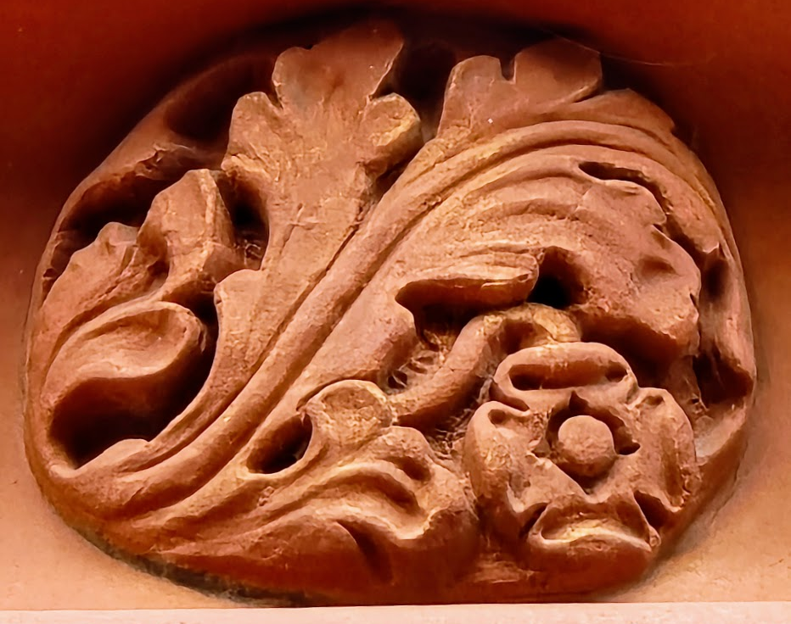
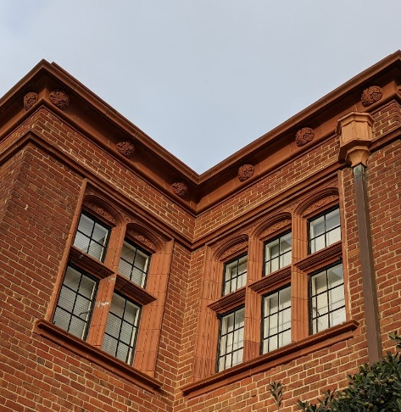
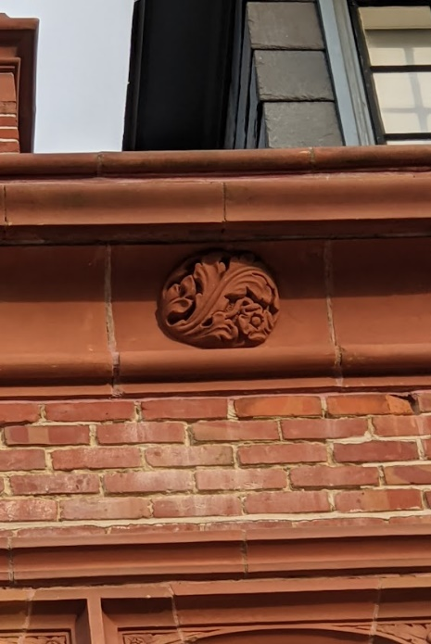

Roses in Two Front Bay Terracotta Panels
Two rectangular terracotta panels are above and below the windows in the central bay. Each bay contains a double rose surrounded by what might be buds. The is decorations are highly undercut indicating a complex manufacturing process. Handiwork is highly evident.
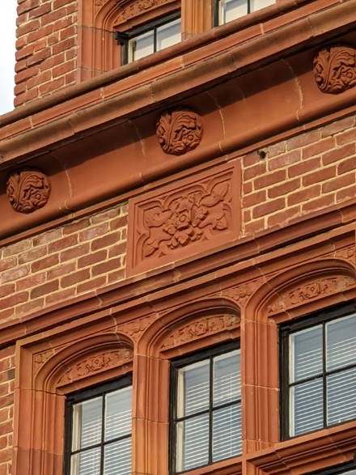
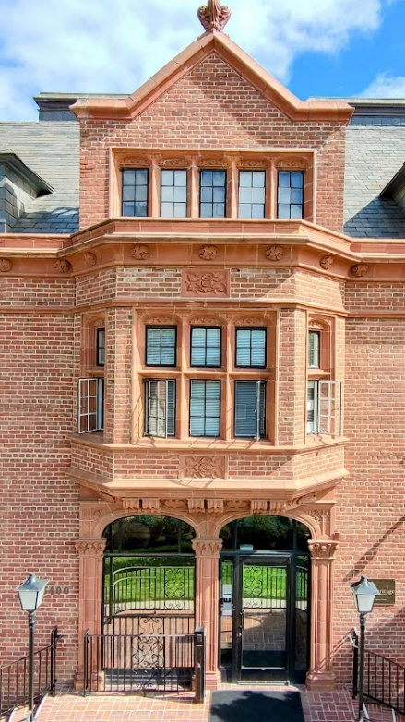

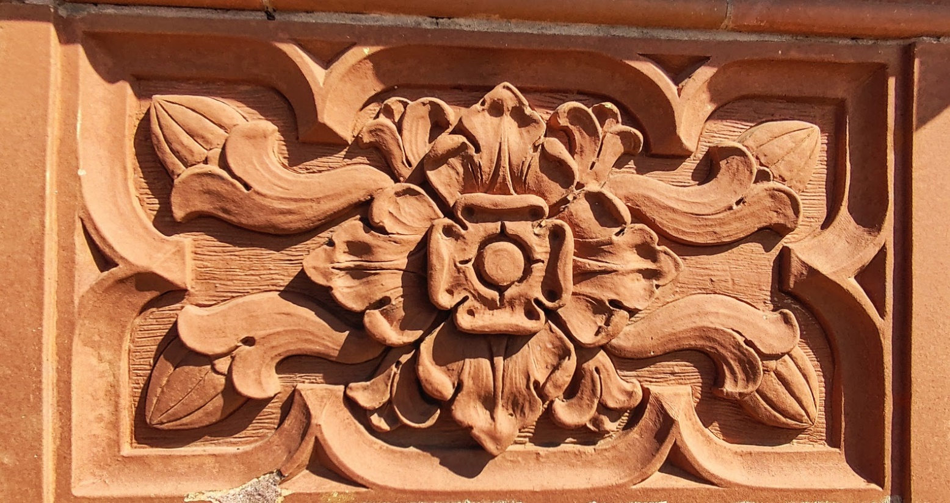

Roses to Both Sides of Six Front Bay Corbels
Under the central bay there are six separate corbels with a single four quadrant rose at each end. The overall shape of the corbel is quite convoluted, indicating the use of a complex casting process. The appearance of a rose at the end is unusual and indicates a specific design intent rather than standard practice.
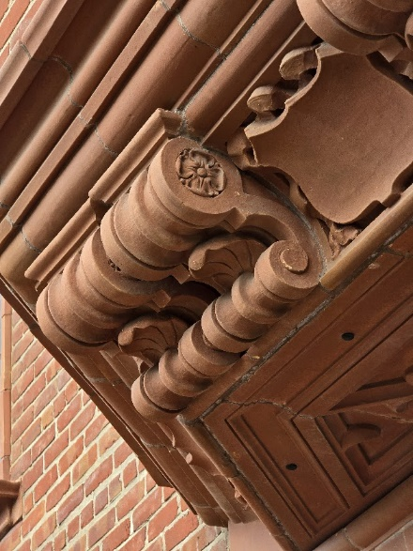
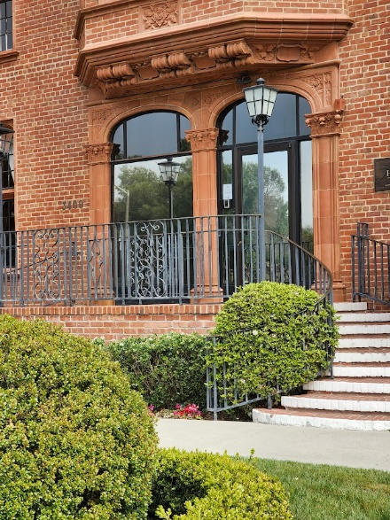

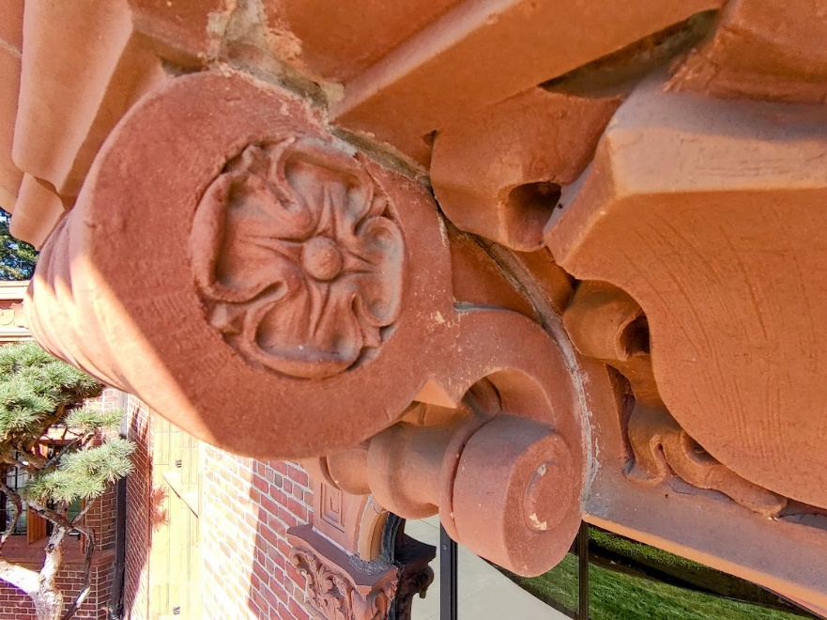

Two Roses in Three Pilaster Capitals
Perhaps the most imaginative application of the rose theme on the Morgan building is the embedding of two single quadrant roses between the traditional acanthus leaves in each of the flat faces of the three pilasters (square columns) that otherwise resemble capitals of the Corinthian order. Significant undercutting is exhibited.

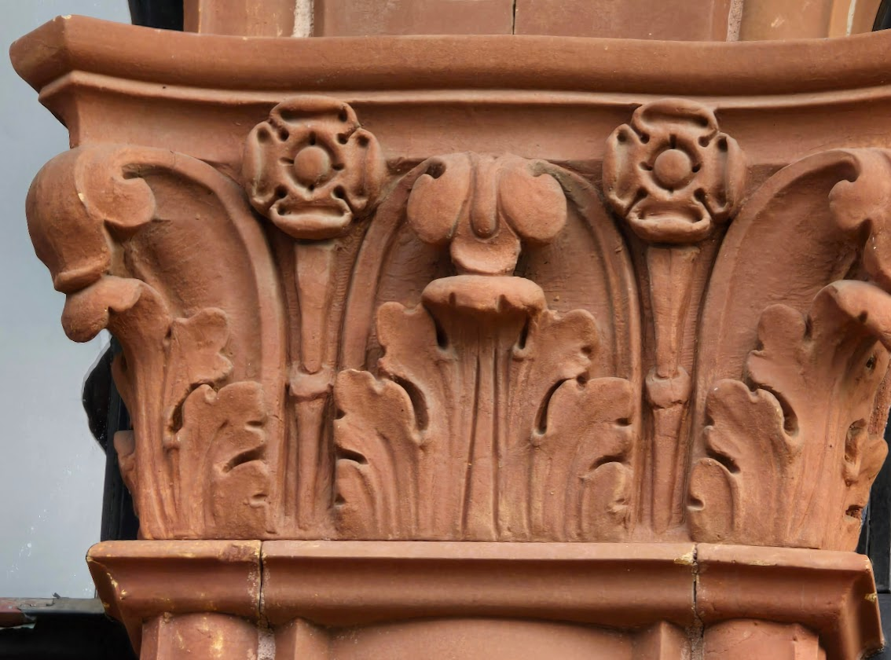

Roses in Spandrels to Front Door Arches
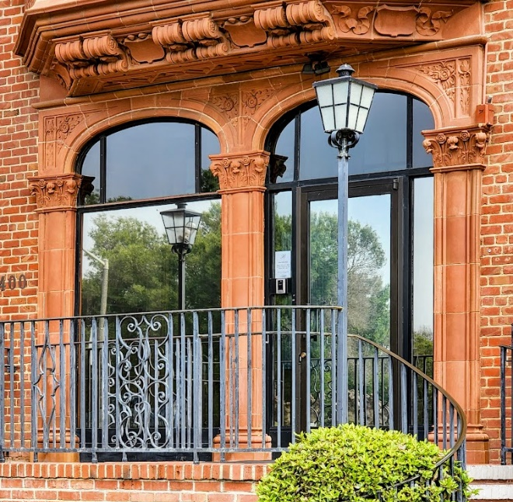
The intricate floral carving to the right of the arch is part of the spandrel, the triangular space between the top of the arch and the rectangular framing of the window. The center and side spandrels differ. The side spandrels add an extra rectangular area with what may be a vertical branch with a rose bud.

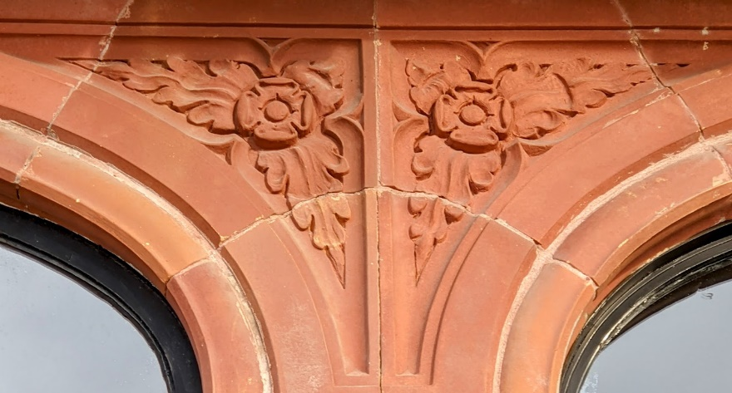
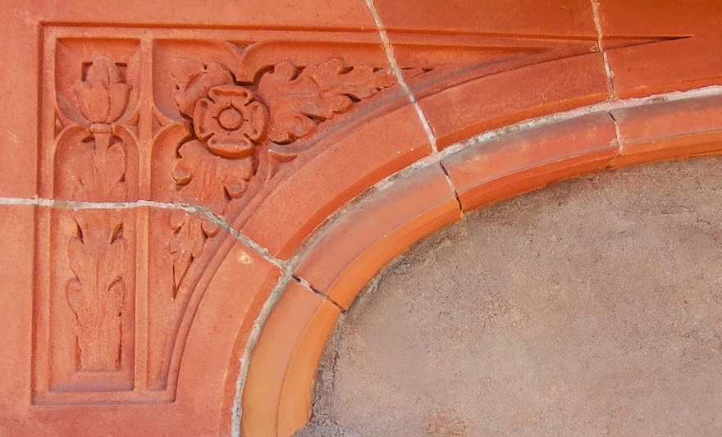
Roses in Window Transoms
The most frequently appearing rose in the building is at the center of every transom of every window. The rose and leaves are highly stylized nevertheless retain the feel of “made by human hands”. Even this most commonly used component in the Morgan Building displays the need for a complex casting process.
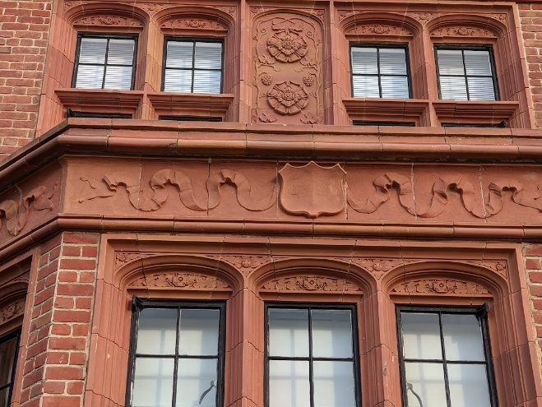

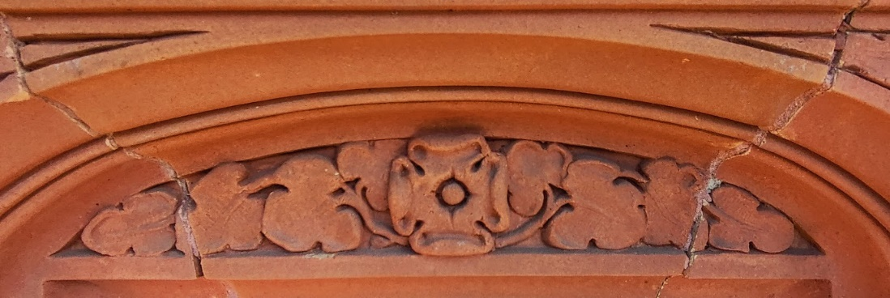

Rosebuds in Window Spandrels
The spandrels are only a few inches wide. The floral decoration looks more like a rosebud than a rose. In any case it has a stylization of leaves and flower that differs from its adjacent architrave.

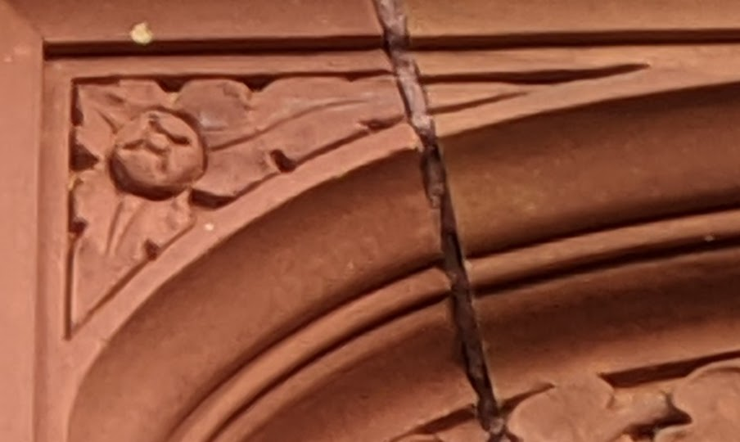

“Roses” in Brickwork
There are two areas of brickwork that incorporate decorative areas that may or may not depict rose-like feelings. ;-)
The most rose-like is on the sooth face of the corridor.
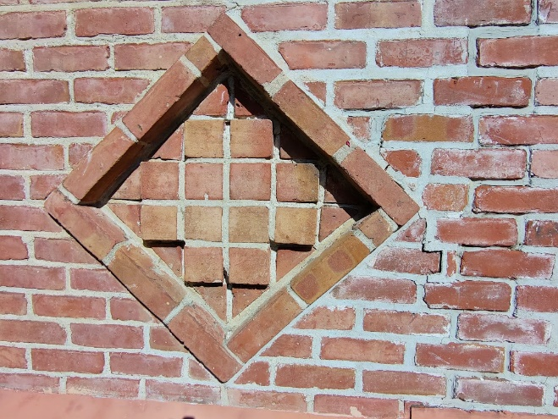
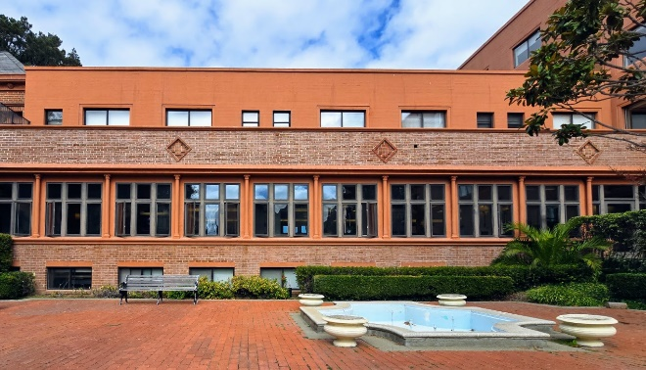

The second rose is on the mostly blank south elevation of the Morgan building
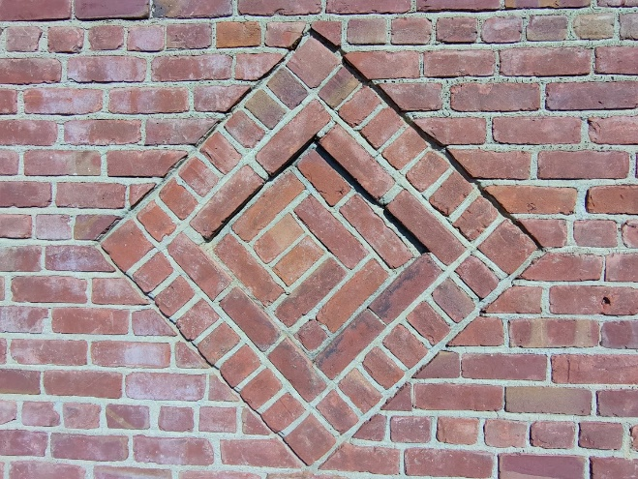

Roses in Corridor Column Capitals
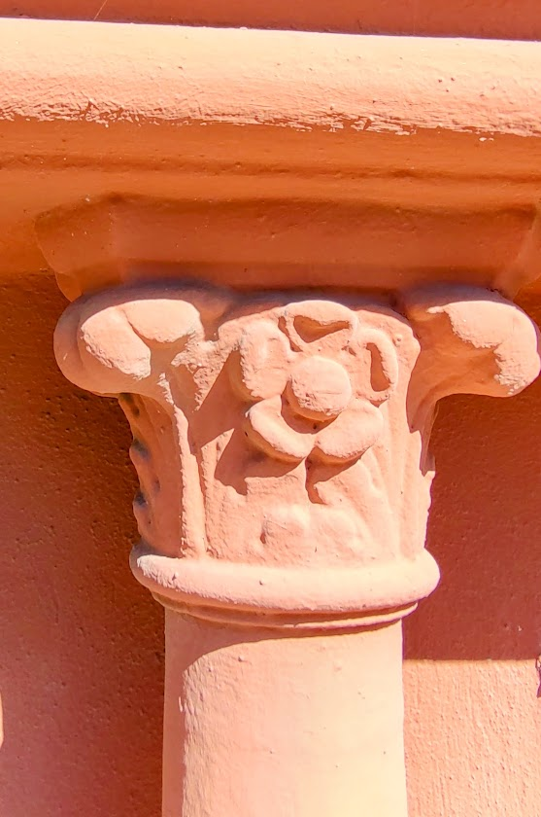
When the Perry Building was added in 1958, a corridor was added as a connector to the Morgan building. The design of the corridor, unlike the Brutalist-style Perry building, incorporates elements that are inspired by Julia Morgan’s efforts. Highly apparent are the crudely-detailed Corinthian column capitals with a rose. Note the five not four rose petals.

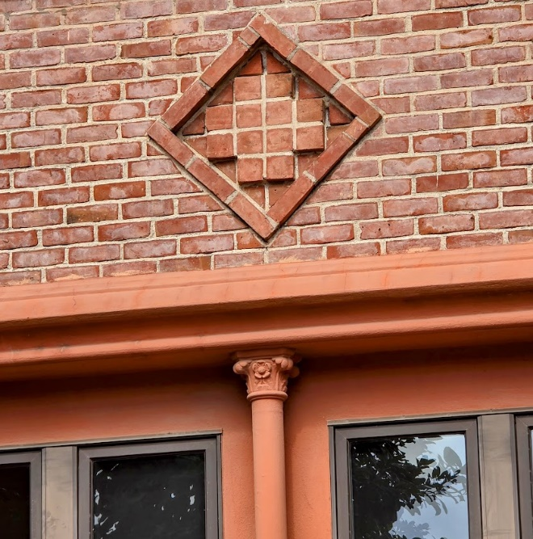

Four Roses in Parlor Mantlepiece
Helping to confirm that the rose them was an architectural design theme and not just the whim of an individual tradesman, roses are evident inside the building made of very different materials. Four stylized quadrant roses double roses adorn the Morgan Parlor fireplace.
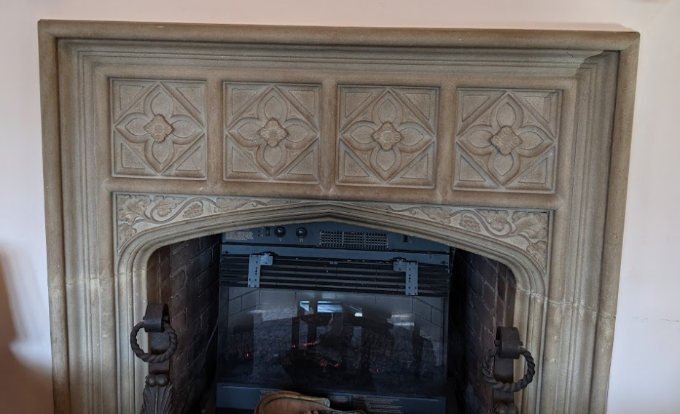
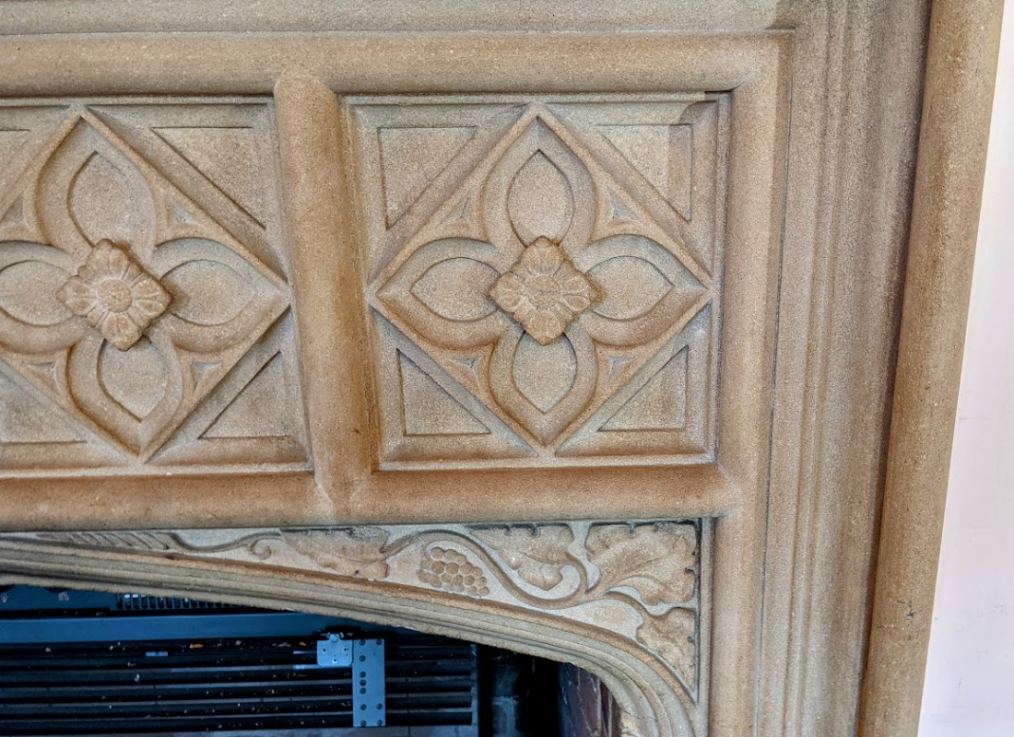

Roses as Brass Ornaments to Fireplace and Windows
In the Morgan Parlor, gold-colored ornaments to both sides of the fireplace. Depicting stylized double roses. Photograph taken in November 2020. The ornaments are no longer in these positions. Ditto similar ornaments in black to both sides of the windows to hold back curtains.
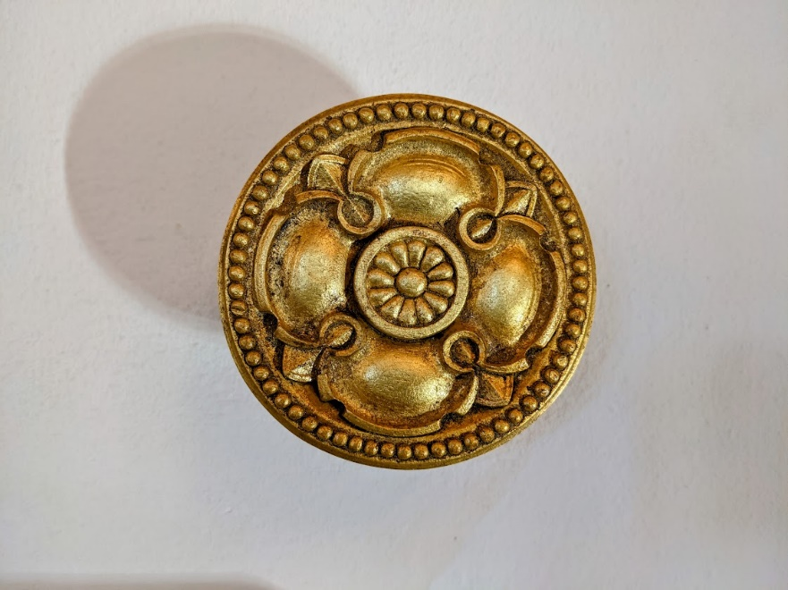
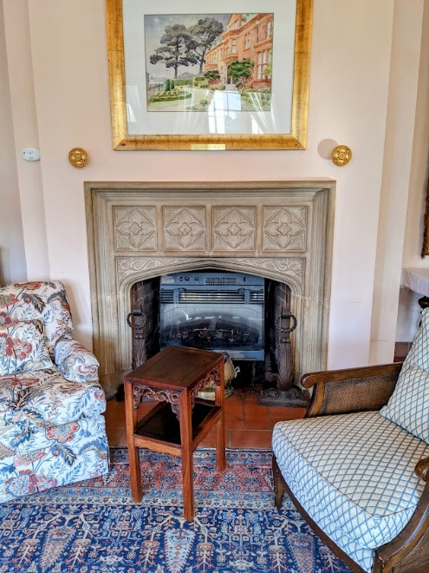

Roses in Folding Screen
On the fourth floor of the Perry Building, there is a folding screen that feels like a 1920s effort. It contains elements that look like stylized roses. More research is needed to help identify this piece as part of the Julia Morgan design.
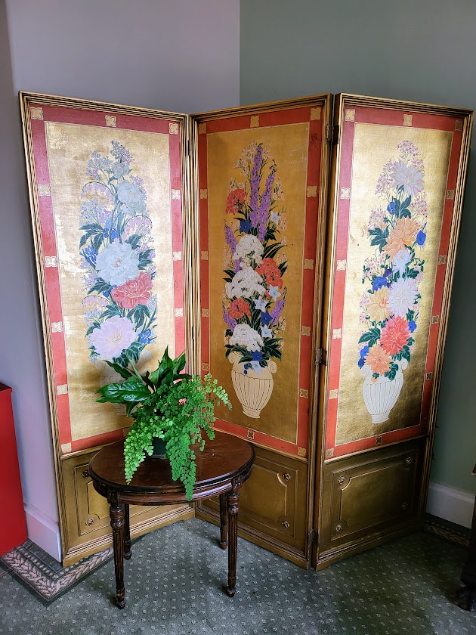
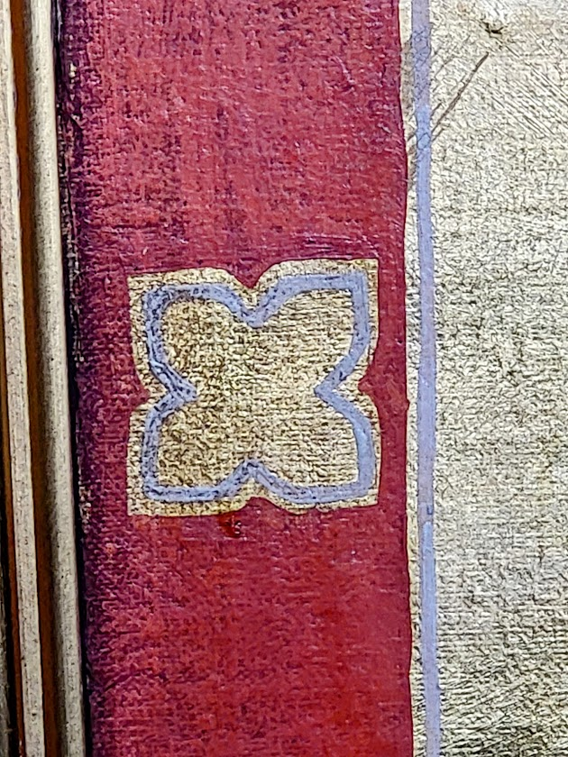
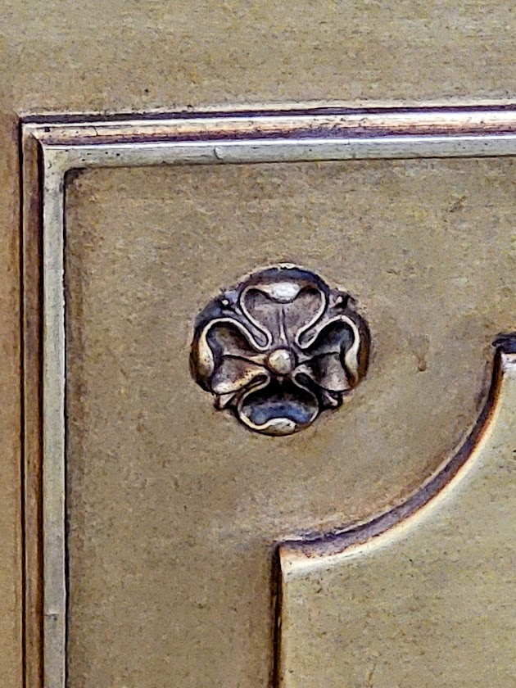

Four Roses in Chapel Alter
The altar in the Chapel which was altered in 1958. The alter table includes four four-sided roses carved in wood. The designer of the chapel understood the importance of the roses.
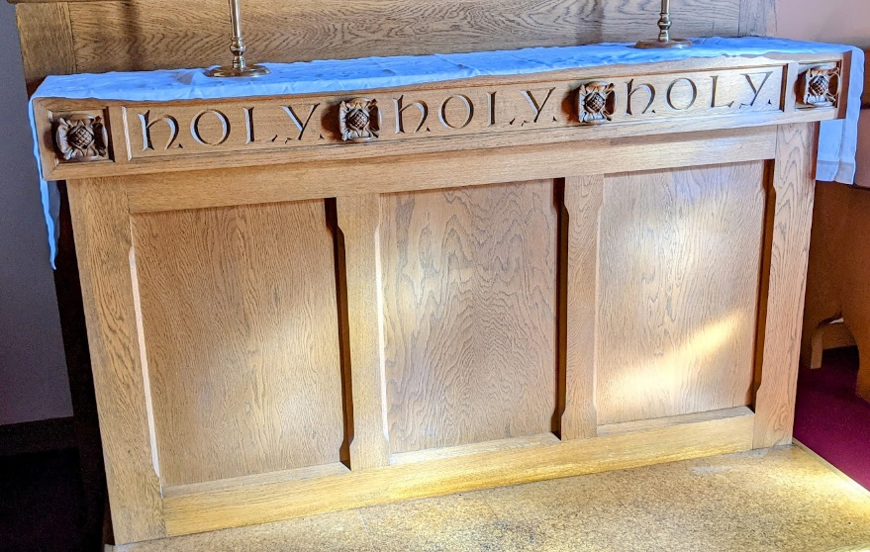
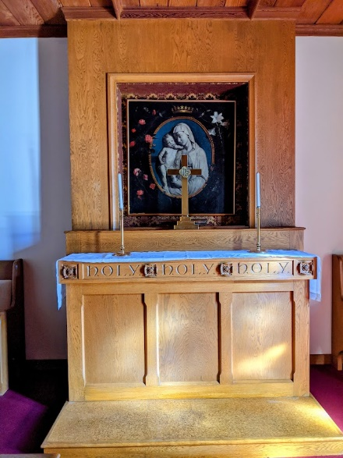

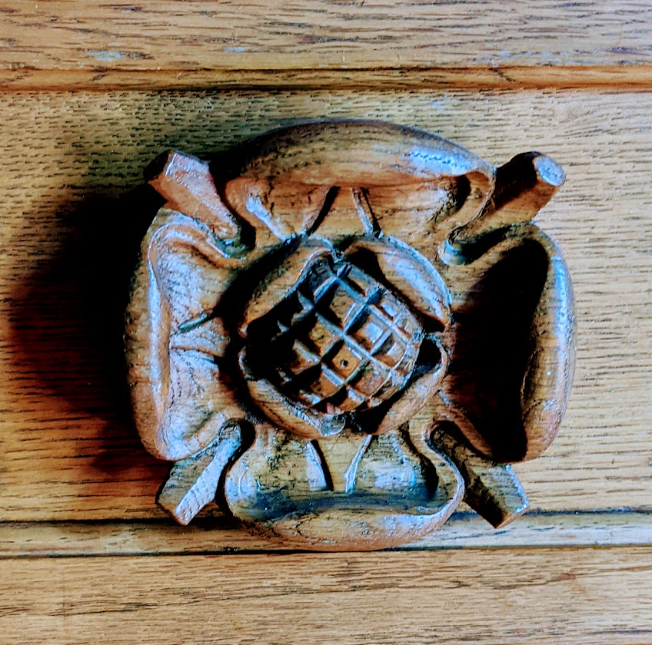

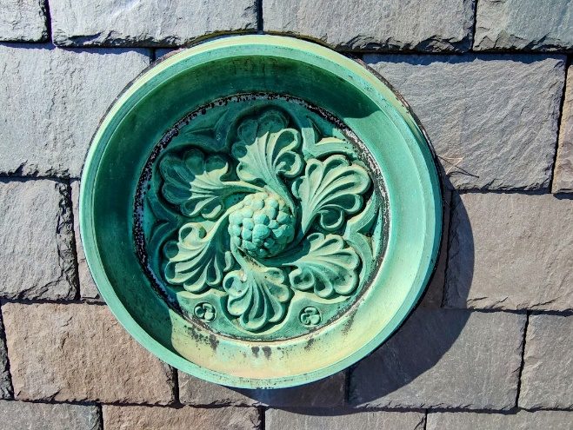
Berries or Grapes in Various Locations
Two quite beautiful copper roundels affixed to roof facing courtyard. Note the large berry in the center.

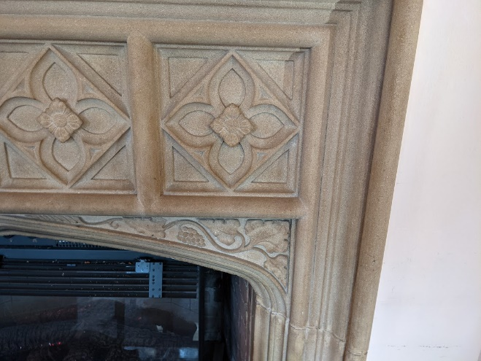
Note the berry or grapes to the spandrel to the right of the arch of the fireplace.

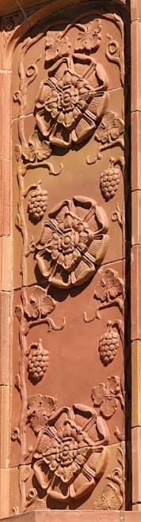
Note the four bunches of grapes or berries

Trefoils in Various Locations
A trefoil is an ornamental design of three rounded lobes like a clover leaf, used typically in architectural tracery.
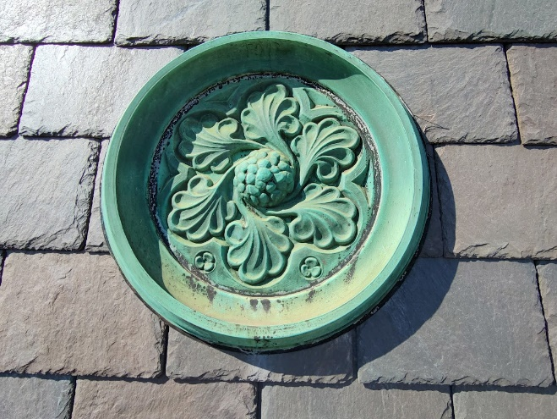
Note two tiny trefoils at 5 and 7 o’clock

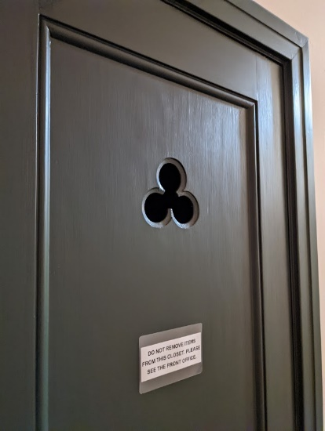
Note two doors with trefoils to left of Morgan building staircase

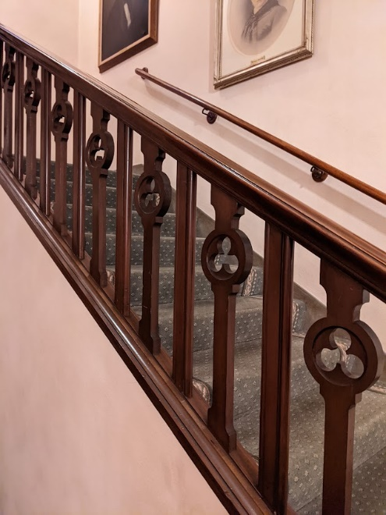
Note alternating balusters with trefoil cutouts

Postscript

Multiple Uses
This paper has multiple intentions, The first, of course, Is to provide further background to the draft EIR. Next, logically. would be to provide any updates that might be of interest to the final EIR and an eventual planning application. Second intent is to provide this background information to the San Francisco historical planning group and the application to become registered in San Francisco. A third intent is to begin to provide some kind of repository or documentation that will be of assistance in celebrating the 2025 centenary of the Julian Morgan building at 3400 Laguna Street.

Photography
My use of technology in this process is a work in progress. I’m using a Samsung Galaxy S24 ultra as one of the cameras and a hover air X one and X 1 pro drone that is my cameras. All of the images are being edited using the AI editing tools in Google photos. Editing includes cropping rotating and adjusting the colors. The tricky thing is adjusting the colors. It turns out that all the cameras take pictures with very different coloring aspects depending on the weather and the time of day. This is fine if you’re looking for wonderful images that stand by themselves. But varying colors can be distracted when you’re looking at a entire paper full of images that are meant to be the same thing. There is much to learn here.

Artisans
The name of Julie Morgan is very well known in relationship to this project. But what about all the artisans and craftspeople that actually created all the decorative elements catalog in this paper? Obviously, some of them were master craftspeople in the field of terracotta, and stonework and the other materials used to build these decorations. As this work progresses, I plan to research this topic in detail. Of course, Julia is the star, but she was helped by many other stars in their own disciplines. It would be good if their names are known and their reputations enhanced.

Colophon
The font for this paper is 14-point Verdana. This is the font we also use to publish the Heritage Happenings, the newsletter sent out to all the residents of Heritage on the marina and other subscribers. It is the font that is most legible to elderly people with vision issues. The hex code for color of the headings is #88000. We call this color “red brick”. Which is of course the primary color of the Julia Morgan building.

